**WEB MINING**

**INVERTED INDEXES**

**16BCE1186**

**HARSH TRIPATHI**

**CODE:**

doc1 = open("one.txt","r")

data = doc1.read()

f1 = data.split()

doc2 = open("two.txt","r")

data = doc2.read()

f2 = data.split()

doc3 = open("three.txt","r")

data = doc3.read()

f3 = data.split()

dict1 = {}

for i in f1:

if i not in dict1:

dict1[i] = [0,0,0]

dict1[i][0]+=1

for i in f2:

if i not in dict1:

dict1[i] = [0,0,0]

dict1[i][1]+=1

for i in f3:

if i not in dict1:

dict1[i] = [0,0,0]

dict1[i][2]+=1

for i in dict1:

for j in range(0,len(dict1[i])):

if dict1[i][j]!=0:

print(i,"->","occurred "+str(dict1[i][j]),"times in document"+str(j))

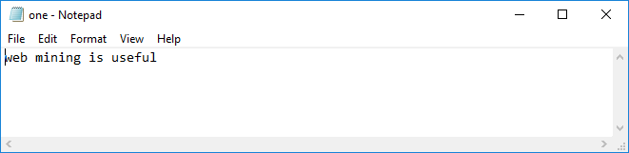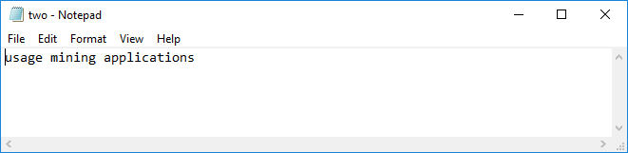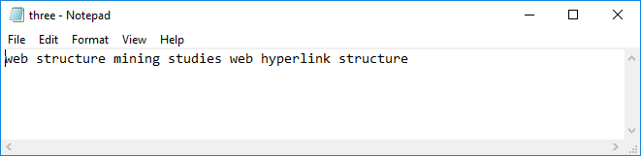

**OUTPUT**

